**1. System of Interest (SOI)**

The system of interest (SOI) for this project is a point-of-sale (POS) system designed to streamline order processing, payment handling, and user authentication for a restaurant setting. The system consists of three main subsystems. The first is the User Interface (UI) Subsystem, which includes various screens and interfaces, such as login, menu selection, and order summary displays. This subsystem enables users, such as employees and managers, to interact with the system seamlessly. The second subsystem is the Business Logic Subsystem. This component handles core functions, including user authentication through NFC, order processing, and payment calculations. The third subsystem is the Database Subsystem, which securely stores and manages data for users, orders, and menu items. This subsystem will maintain data integrity and provide easy access for quick retrieval by other components. Together, these subsystems create a cohesive POS system that enhances the efficiency of restaurant operations by simplifying key processes.A diagram of a credit card processing process

**2. Describe the Environment**

The POS system is designed to integrate smoothly within the restaurant's technological environment, supporting its operational requirements while interfacing with existing systems. Within the restaurant, this POS system will interact with other essential technologies, such as inventory management and accounting software, which are vital to tracking inventory levels and recording financial transactions, respectively. For example, when an order is placed and processed through the POS system, this transaction data can be sent to the inventory system to update stock levels in real-time. Additionally, the POS system will be compatible with external payment processors, allowing it to accept various payment methods (e.g., credit cards, mobile payments). As a result, the POS system will improve communication between the restaurant’s existing technology infrastructure and its operational needs, enhancing overall efficiency and accuracy.

**3. Design the Application Components**

The proposed POS system is divided into subsystem components that interact cohesively to fulfill system requirements. The main parts of the POS system include the User Interface (UI) Layer, the Business Logic Layer, and the Data Access Layer. Each component has a distinct role. The UI layer handles the visual interface for users, including screens for login, menu browsing, order summary, and payment options. The Business Logic Layer is responsible for processing operations such as verifying user credentials, calculating order totals, and managing transaction details using NFC readers. The Data Access Layer interfaces with the database, retrieving and updating data such as user records, order histories, and menu items. This modular design allows the system to be both scalable and maintainable, supporting future expansions if needed.A screenshot of a computer screen

**4. Design the User Interface**

The app shown below is a prototype of what our idea is. We will update the app in the next deliverable and will have the UI updated. Below is roughly how are project will function.  
<https://www.youtube.com/watch?v=aEXc4LwPrr8&ab_channel=MarvinDeLaCruz-Serrano>

[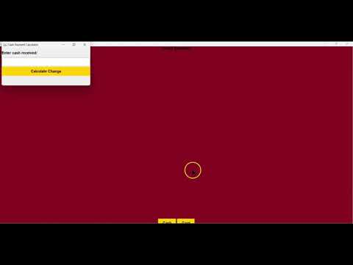](https://www.youtube.com/embed/aEXc4LwPrr8?feature=oembed)

**5. Design the Database**

**6. Design the Software Classes and Methods:**

